Contents

Connect to OpenEphys GUI 1

Preparation for craniotomy 2

Stereotaxic Surgery 3

Implant probe 6

Types of Artifact: 9

References 10

# Connect to OpenEphys GUI

1. Connect power and USB-D connecter to computer.
2. Run OpenEphys GUI exe.
3. Load xml workflow from github. **DO NOT enable reload on startup!**
4. Check settings/headstage connection. Check channel mapping.
5. **Check PATH** of file save configuration. Should be external drive.
6. LEDs of acquisition amplifier should be illuminated.
7. Run acquisition. **DO NOT enable reload on startup!**
8. Stop to verify that bandpassed data is saved.

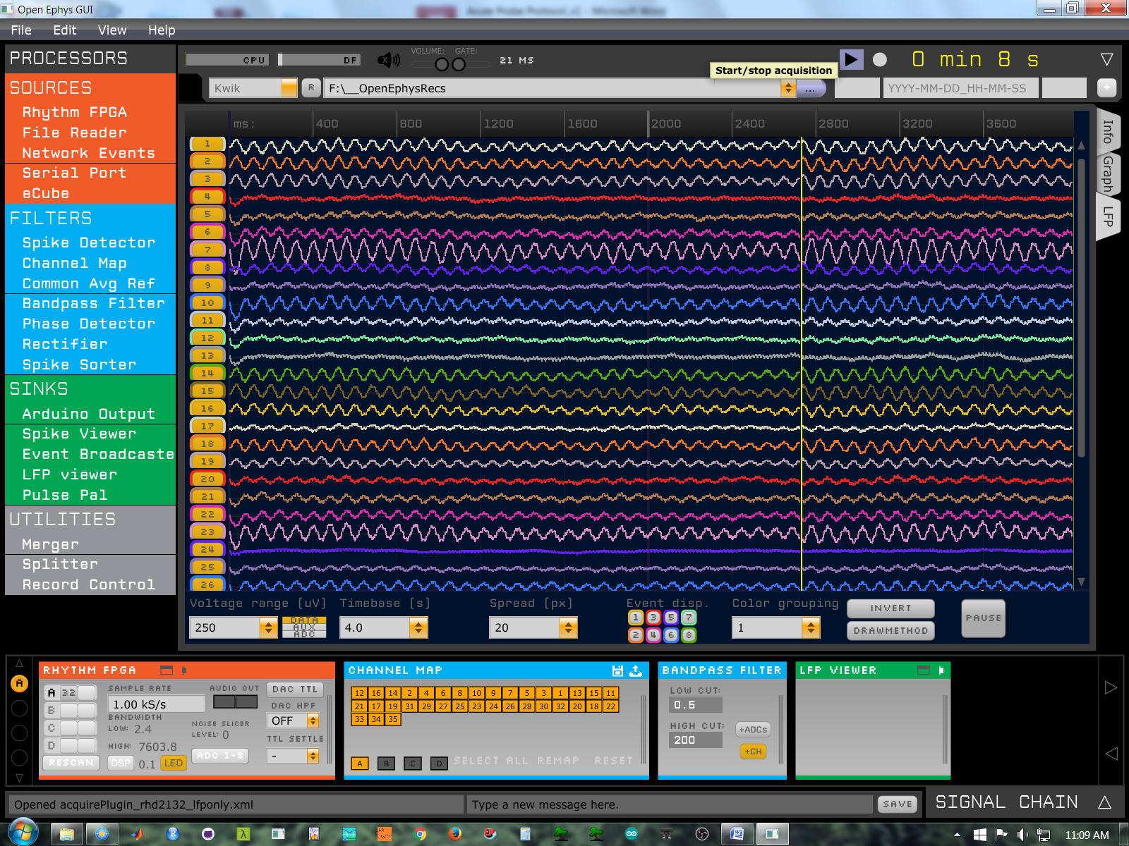

# Preparation for craniotomy

1. Turn on heat sterilizer.

Left side (bead sterilizer, eye ointment, beta-iodine)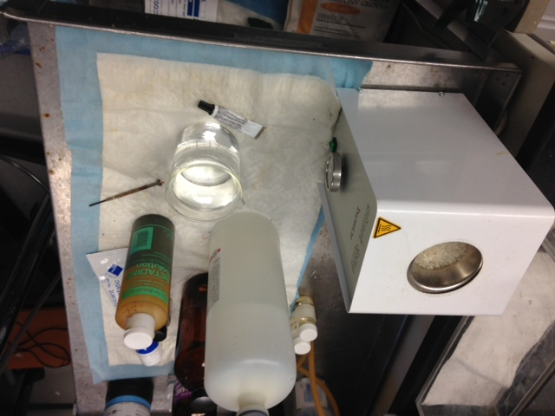

Left side: bead sterilizer, eye ointment, beta-iodine

1. Check for all required surgical tools.

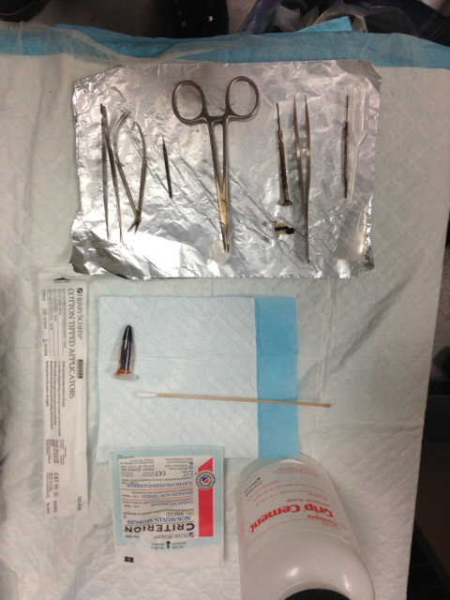

Surgical Tools: bent serrated forceps and microscissors; drill bit, hemostat & plastic cup (mix grip cement); flathead screwdriver & straight forceps; cement applicator and short transfer pipette, sterile cotton swabs (x2), sterile gauze (x2), grip cement and solvent.

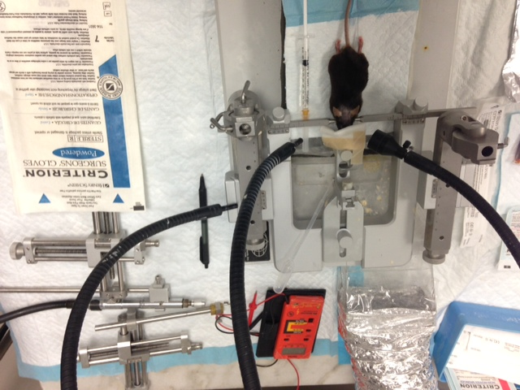

Stereotactic frame setup: mouse in frame on thermal pad. Surgical gloves, right arm w/ drill, left arm with clamp (to hold implant), multimeter (connectivity test), air vent, heated lactated ringer for post-surgical recovery.

# Stereotaxic Surgery

1. **CURRENT ANESTHESIA**: Anesthetize animal with isoflurane inhalation. Turn on O2 tank (verify psi). Set O2 regulator (“4” setting).

|  |  |  |
| --- | --- | --- |
|  | O2 flow  setting | Isoflurane flow setting |
| Knock down Box | **“2.5”** | **“3”** |
| In stereotaxic frame (nose cone) | **“1”** | **“2”** |

1. Ground animal from heat blanket using aluminum foil:

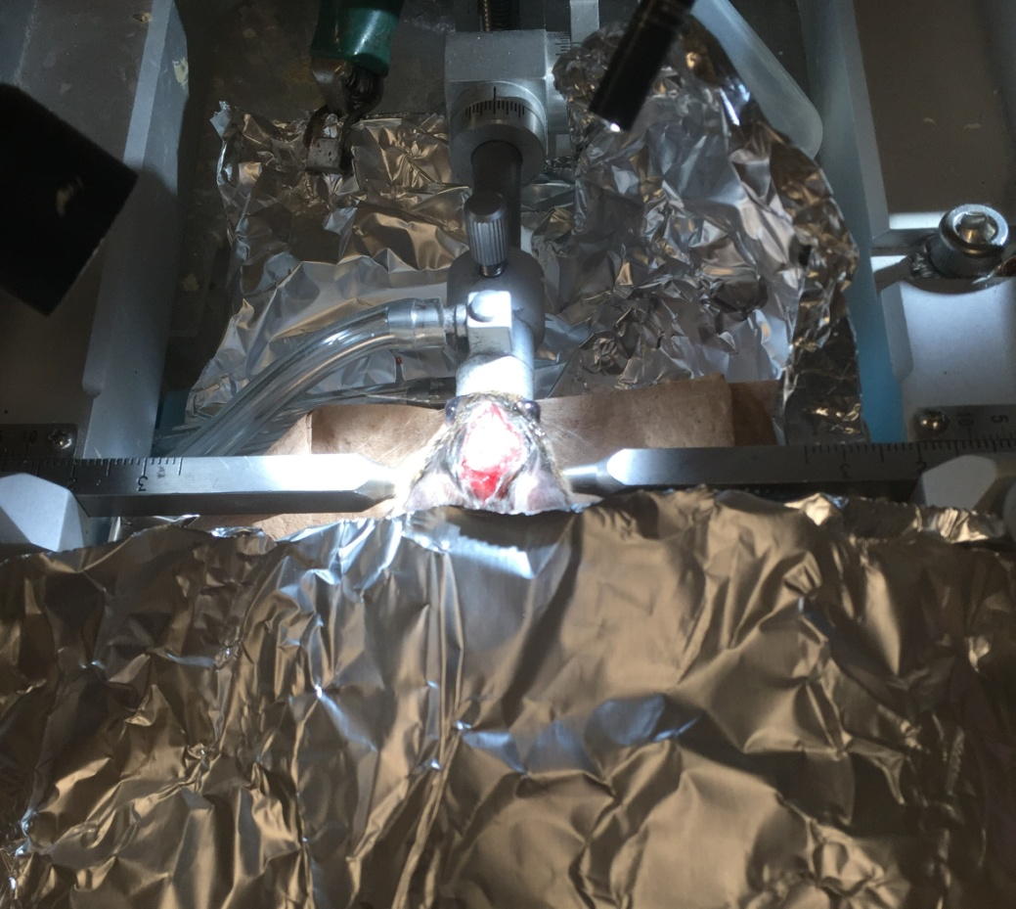

1. When in stereotaxic frame, inject buprinex (SQ): 0.1 mL (30g mouse) and ketofen (SQ): 0.1 mL
2. Monitor breathing (want constant breathing, ie no gasping). **Monitor depth by tail pinch, foot pinch, and then eye blink** (light anesthetized). Animal should not respond, but should have 0.5-1Hz respiration.
3. Shave head with trimmer.
4. Place in stereotaxic frame. Ensure teeth/mouth in bite bar. Lightly clamp nose bar.

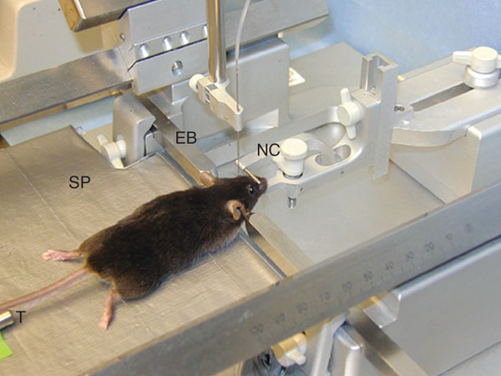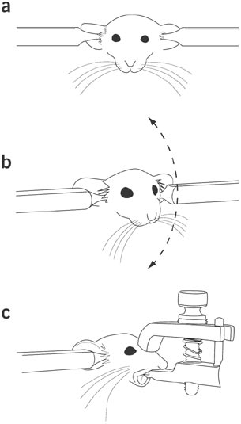

1. Evenly affix right and left ear bars.
2. Apply eye ointment.
3. Adjust jaw/snout to align L & R orbital sockets.
4. Tighten nose bar when straightened.
5. T**est anesthetized animal response by tail pinch**.
6. Apply iodine to dorsal surface of head.
7. Make midline cut with forceps/scissors to expose the skull. Cut and push away the periosteum (clear film/fascia).
8. Expose skull surface w/ forceps. Use clean/dry cotton swab to dry surface of skull.
9. Place gauze over the eyes & turn on
10. Align A-P plane: For Bregma and Lambda, respectively: measure X position and Z position.

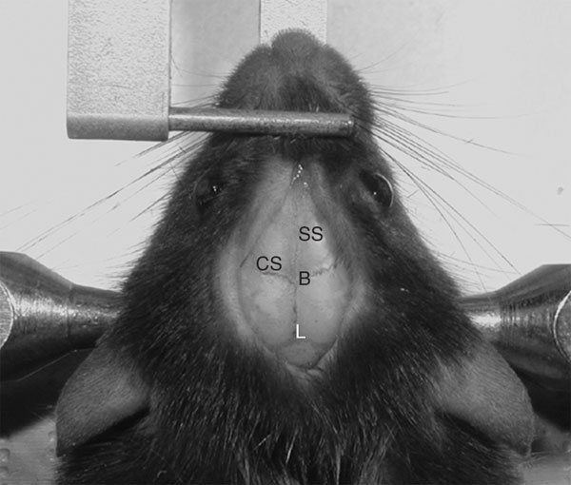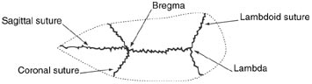

**B to L:**

4.21 mm per Paxinos & Franklin, Mouse Brain in Stereotactic Coordinates

Figure - Rodent skull surface diagram includes the sagittal, coronal and lambdoid sutures defining the stereotaxic landmarks bregma and lambda.

1. Verify alignment by measuring Bregma and Lambda coordinates. Y and Z coordinates should be the same.
2. To align tilt (Y direction), position drill bit in center of B/L. Measure Z direction 2mm left and 2 mm right of center. E.g. if center = 40.0, then find Z @ 38.0 and Z @ 42.0. Proceed if Z38.0 = Z42.0.
3. Input into record sheet (Excel).
4. Drill holes according to stereotactic coordinates (Excel).
5. **Score skull with scalpel to improve adhesion to cement. This is important for long-term adhesion.**
6. Drill at desired coordinates (e.g. for right hippocampus):

|  |  |  |
| --- | --- | --- |
| Measured | Desired | To Drill |
| 44.9 | -2 | 42.9 |
| 40.0 | +2 | 42.0 |
| 11.0 | -1 (starting), scroll to -2.5 | 11.0 |

# Implant probe

1. After drilling ref/gnd holes, insert screws. Add cyanoacrylate glue to screw holes.
2. Make base foundation of cement with copper mesh flaps:

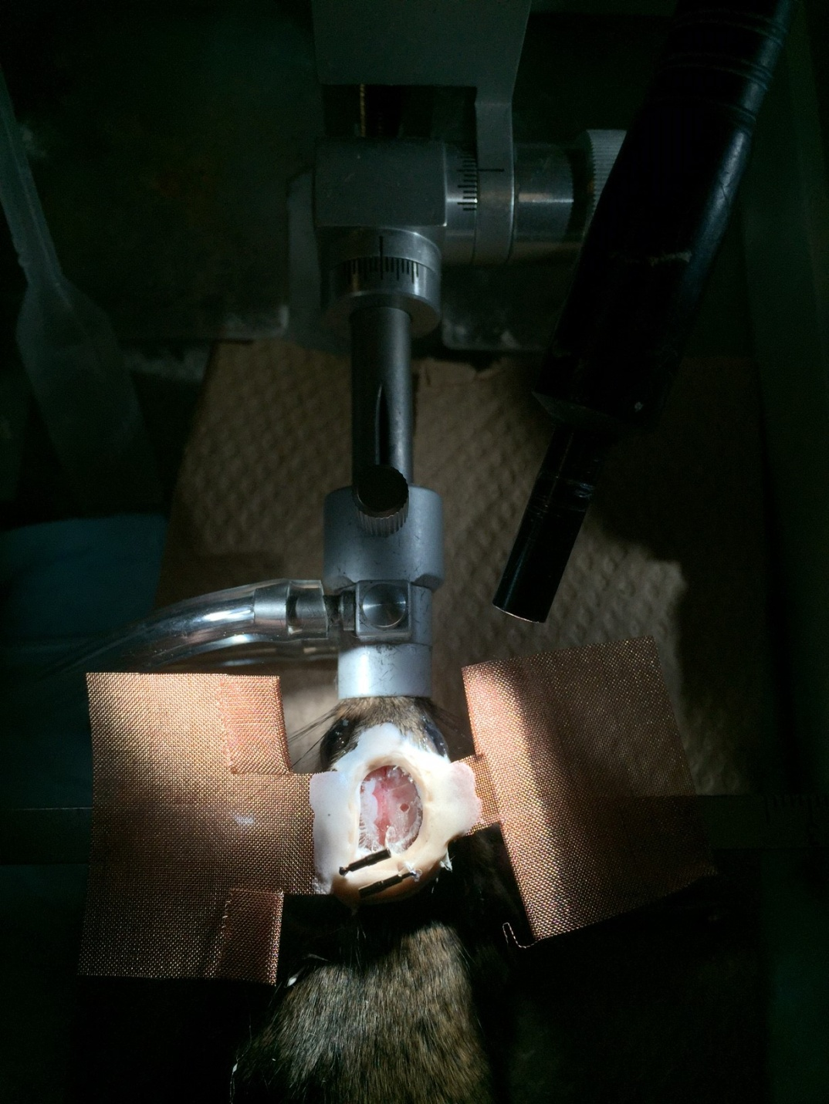

1. Connect probe to adapter. Test noise levels in GUI.

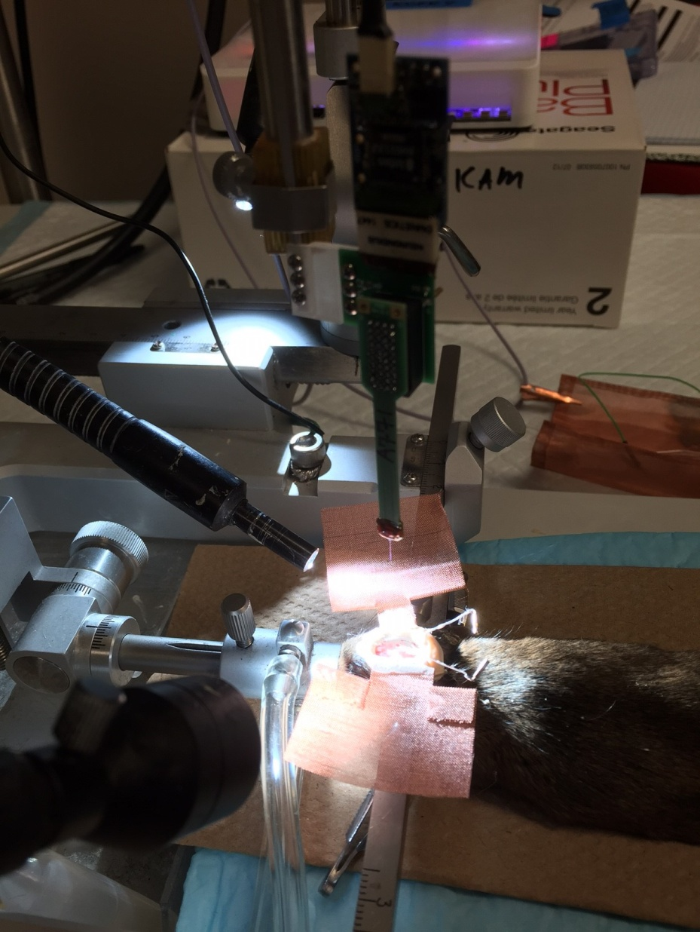

1. Attach copper mesh around headstage. Connect copper mesh to ground (via frame):
2. Connect probe/headstage to Reference (**PR pin in headstage to REF screw over cerebellum**). Connect mesh GND to headstage GND (**GND headstage pin to copper mesh**):

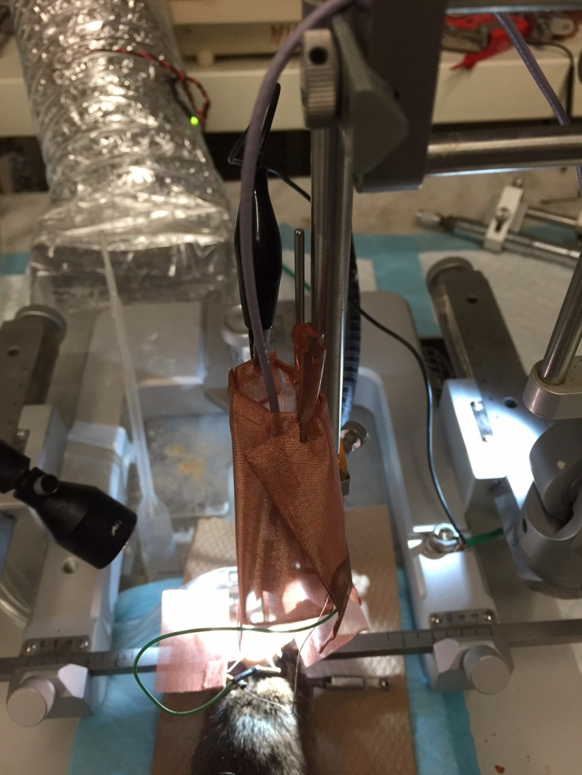

1. Wrap copper mesh tightly at top of adapter to minimize conducted noise and clip in place:

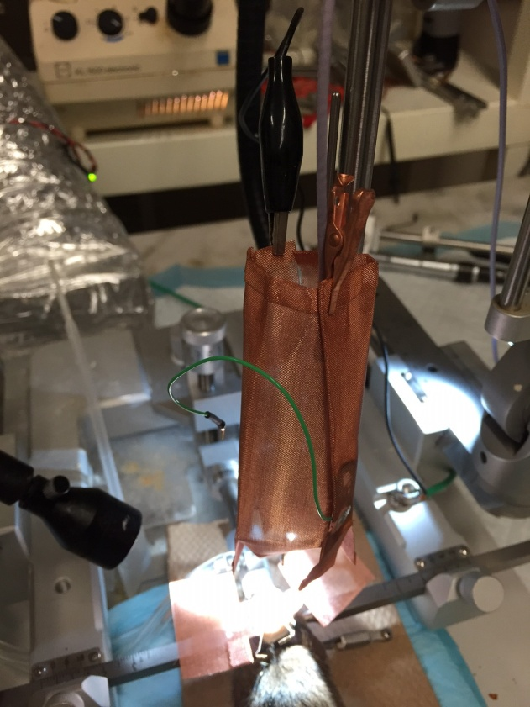

1. Test Noise in GUI. Should be flat @ 250uV:

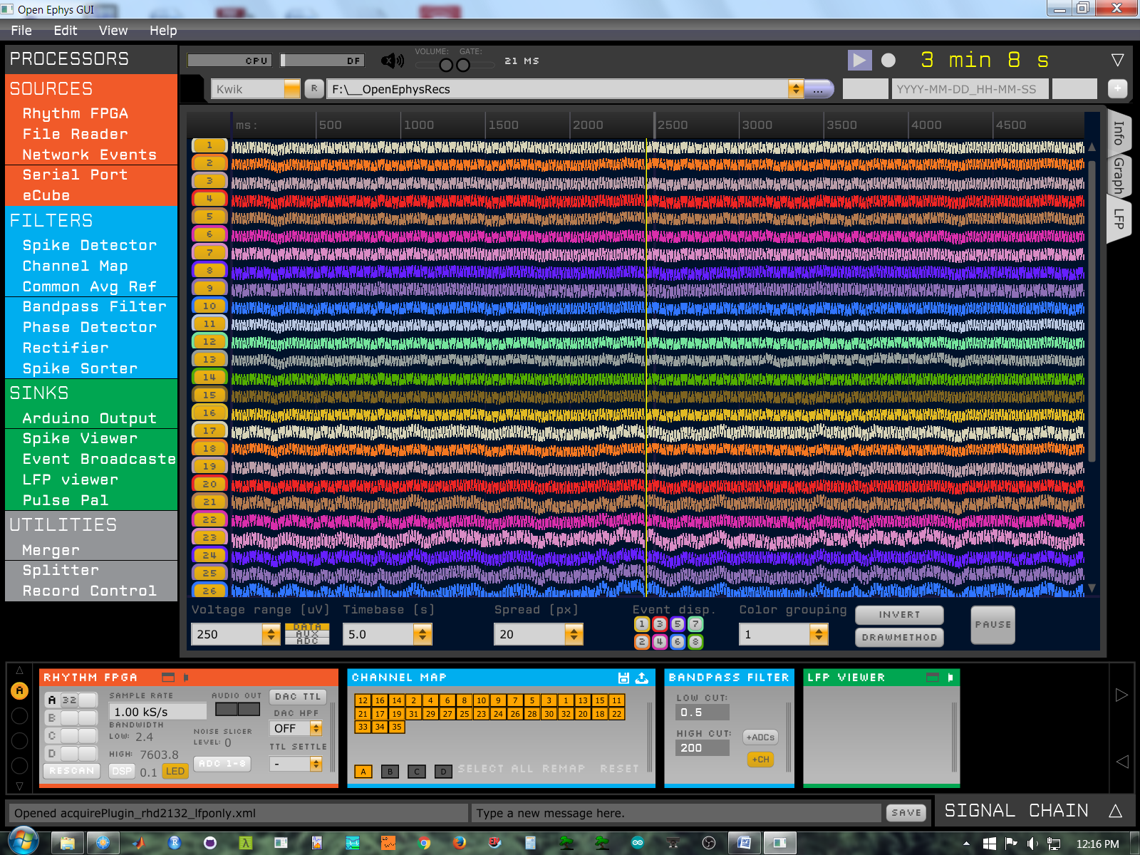

1. Before lowering probe, **test anesthetized animal response by tail pinch**.
2. Lower probe slowly into drilled location.
3. Record start position in Z-plane above brain entry (e.g. @ 57.1 in Z).
4. Begin GUI.
5. **Slowly lower and watch deflection**. Initially the probe bends, and then straightens as it enters brain.
6. After probe has entered, look for physiological signals under anesthesia (delta waves):

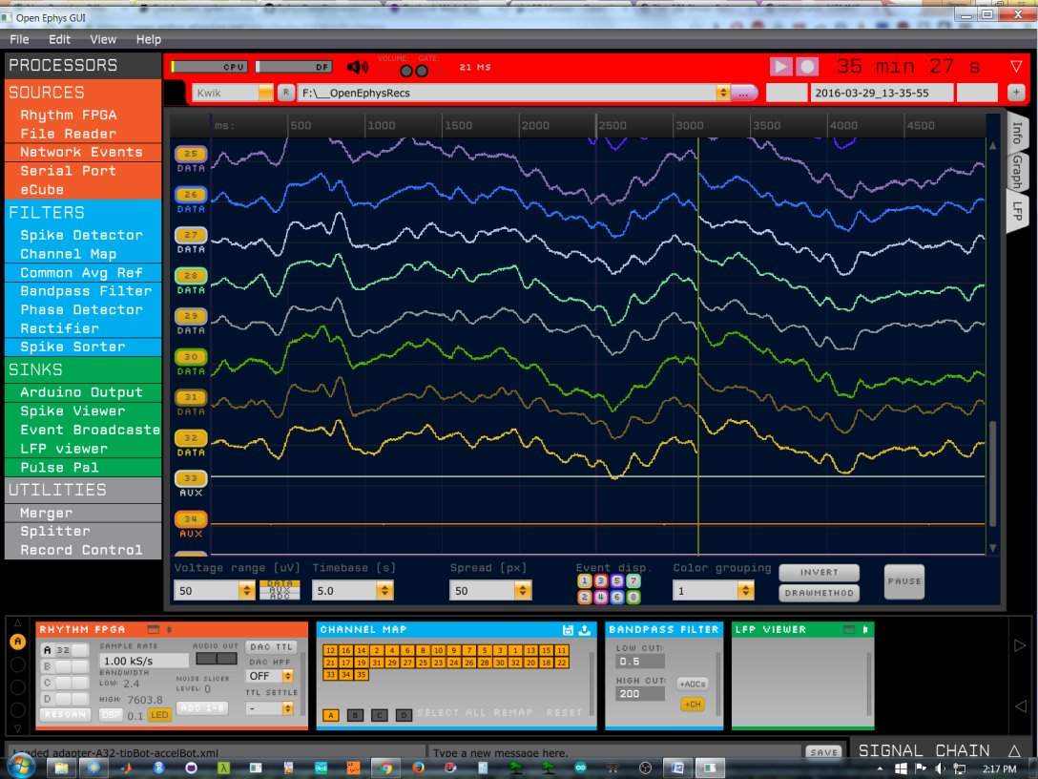

1. Start recording and keep notes, e.g.:

|  |  |  |  |  |
| --- | --- | --- | --- | --- |
| **Exp#** | **Depth (Z-axis)** | **Estimated region** | **Iso level (%)** | **Duration of recording** |
| 1 | 55.5 | CA1 | 2.0 | 10 min |
|  |  |  |  |  |
|  |  |  |  |  |
|  |  |  |  |  |

# Types of Artifact

Respiration slow wave (use 1Hz high pass):

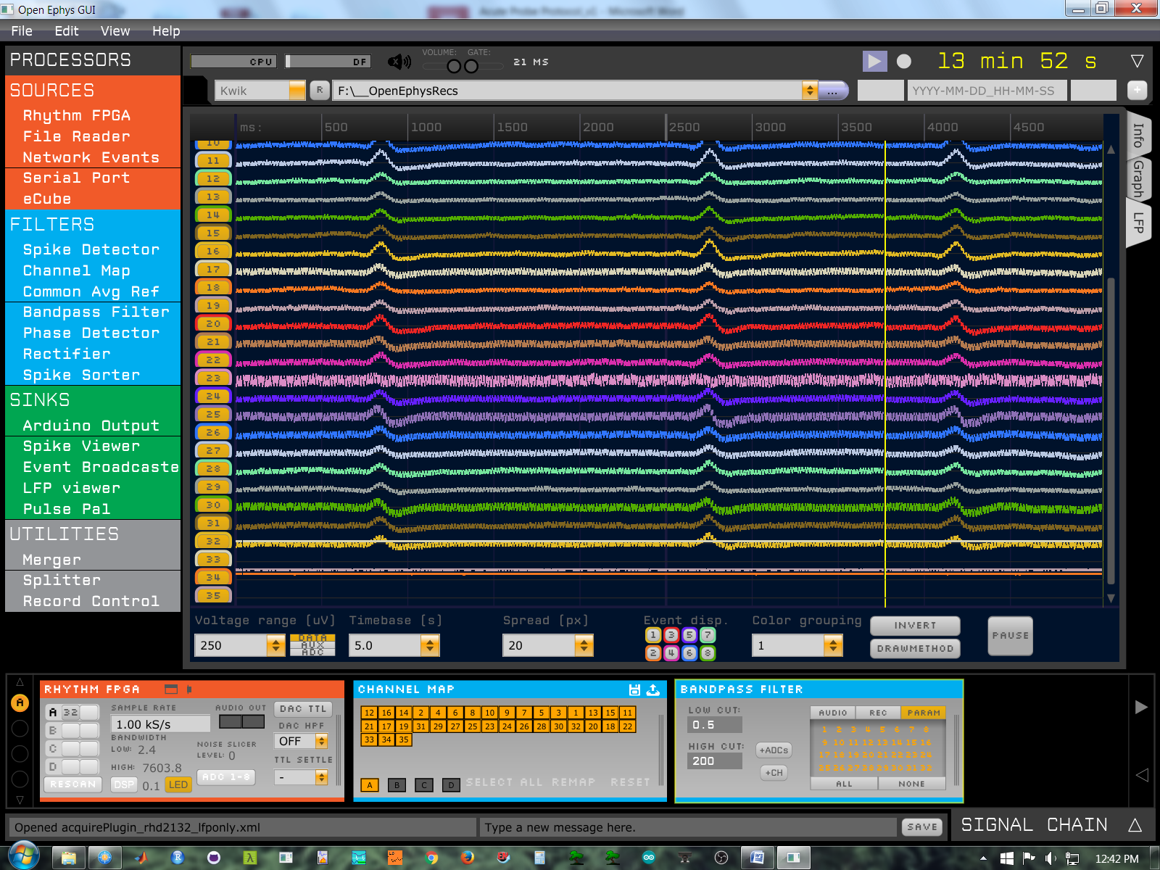

Map channels of adapter (ground one pin, record):

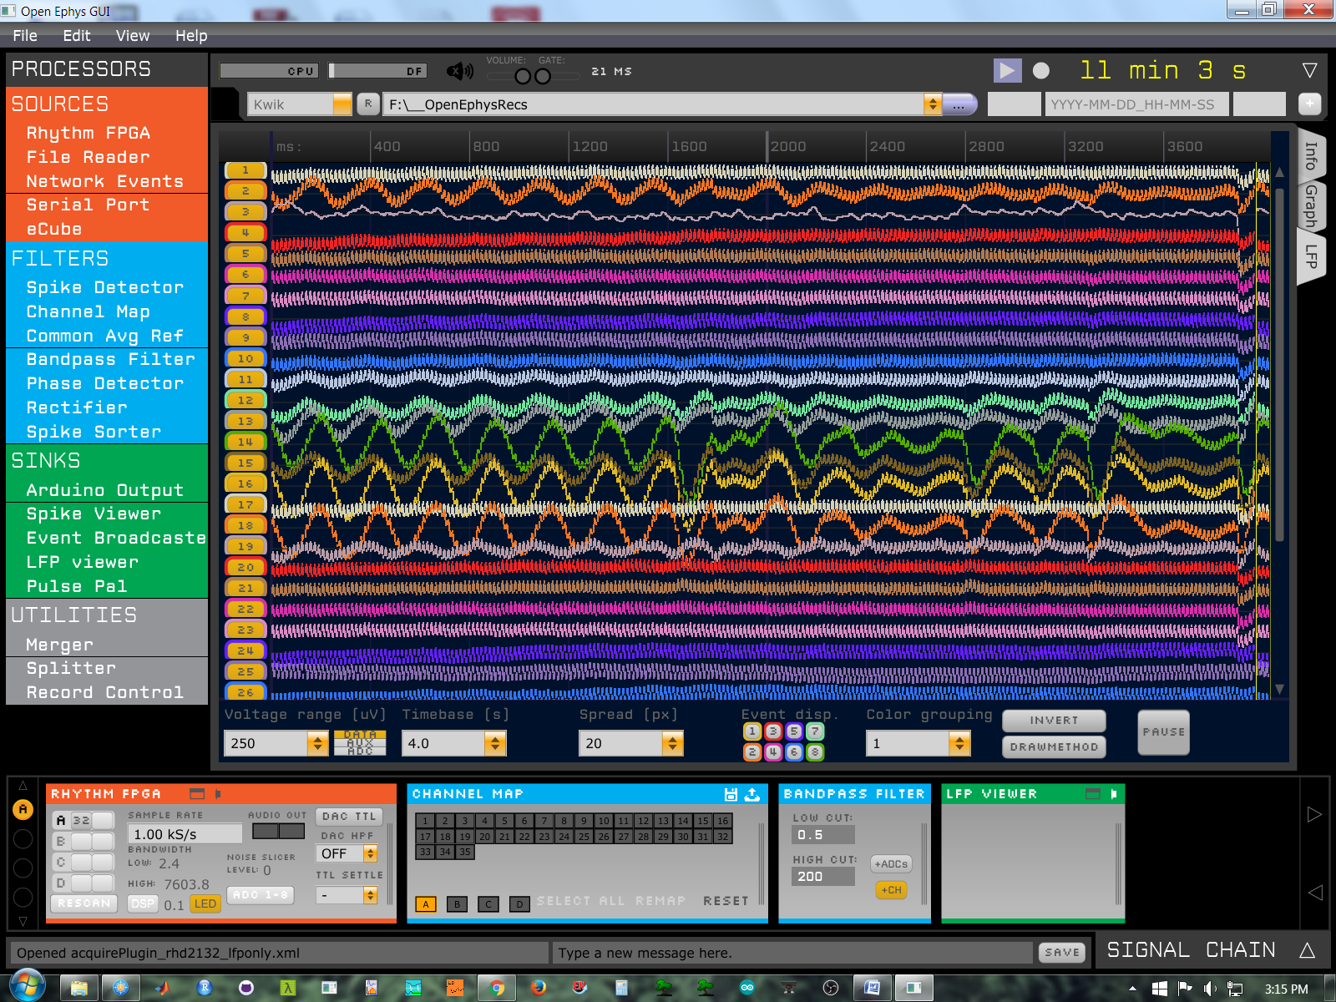

Leave as standard channel map. Only remap post-acquisition. If try remapping, the ref is screwed up (Chan 35 is Pin 1):

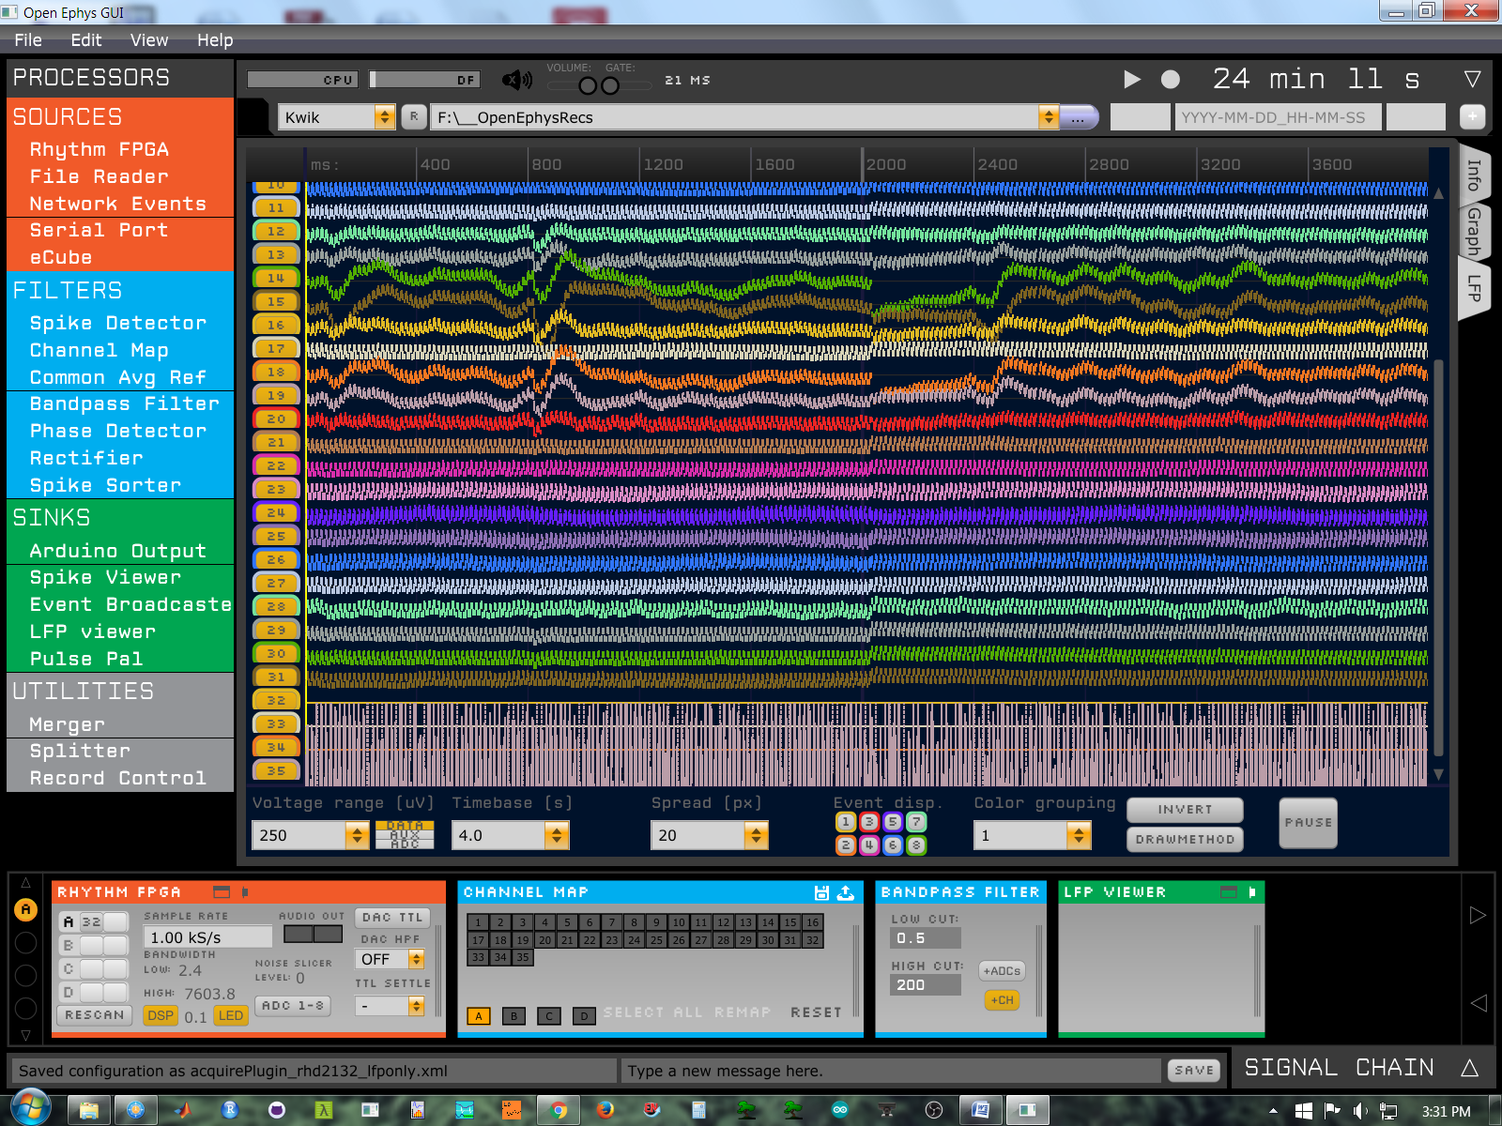

# References

* <https://open-ephys.atlassian.net/wiki/display/OEW/Individual+modules>
* Nicolelis MAL, editor. Methods for Neural Ensemble Recordings. 2nd edition. Boca Raton (FL): CRC Press/Taylor & Francis; 2008. Chapter 2Surgical Techniques for Chronic Implantation of Microwire Arrays in Rodents and Primates. Laura M. O. Oliveira and Dragan Dimitrov.
* Nicolelis MAL, editor. Methods for Neural Ensemble Recordings. 2nd edition. Boca Raton (FL): CRC Press/Taylor & Francis; 2008. Chapter 5 Chronic Recordings in Transgenic Mice. Kafui Dzirasa.
* Curr Protoc Mouse Biol. 2012 Mar 1;2(1):55-74. doi: 10.1002/9780470942390.mo110126. Sleep and EEG Phenotyping in Mice. Mang GM, Franken P.
* J Neurosci Methods. 2009 Mar 15;177(2):355-60. doi: 10.1016/j.jneumeth.2008.10.020. Epub 2008 Nov 1. Neck electromyography is an effective measure of fear behavior. Steenland HW, Zhuo M.
* Methods Mol Biol. 2012;821:373-91. doi: 10.1007/978-1-61779-430-8_24.
* Video-EEG monitoring methods for characterizing rodent models of tuberous sclerosis and epilepsy. Rensing NR, Guo D, Wong M.
* Curr Protoc Mouse Biol. 2012 Sep 1;2(3):273-94. doi: 10.1002/9780470942390.mo120089. In Vitro and In Vivo Recording of Local Field Potential Oscillations in Mouse Hippocampus. Forsyth LH, Witton J, Brown JT, Randall AD, Jones MW.
* Nat Protoc. 2006;1(6):3166-73. Stereotaxic gene delivery in the rodent brain. Cetin A, Komai S, Eliava M, Seeburg PH, Osten P.
* [**A mouse model of intracerebral hemorrhage using autologous blood infusion**](http://www.nature.com.ezproxy.med.nyu.edu/nprot/journal/v3/n1/full/nprot.2007.513.html)